

Schooljaar: 2018 – 2019

Datum test / examen:

…

. / .... / ....

Leerkracht :

Bruno SEYS

**Afdeling**

:

**HBO5 INF**

Module

:

**C4 Internet Technologie**

Naam cursist: **Desmet Tom**

Handtekening:

Puntenoverzicht

Permanente evaluatie

/

Schriftelijk examen

/

Mondeling examen

/

Totaal

/

Te herleiden naar

/



**HTTP POST Request - Apache Web Server - BASH CGI's Task**

Index

Preparations/Info: 2

Task: 3

Result: 3

# Preparations/Info:

The instructor provides you a set of files:

- encode_to_base64.html

- encode_to_base64_students.cgi

- bash_CGI_parsing_GET_and_POST_requests.pdf

- GET_POST_parsing_EXPLAINED.cgi --> reference script to parse GET & POST methods in BASH CGI

- Some screenshots

* Ensure Apache Web Server is operational and the cgi module is enabled.

# 

* Copy "encode_to_base64.html" into your DocumentRoot (/var/www/ ?) and
* "encode_to_base64_students.cgi" into the "/usr/lib/cgi-bin directory".



* Rename the "encode_to_base64_students.cgi file" to "encode_to_base64.cgi".



* Ensure the cgi file is executable (Eventually do a "sudo chmod 755 encode_to_base64.cgi").

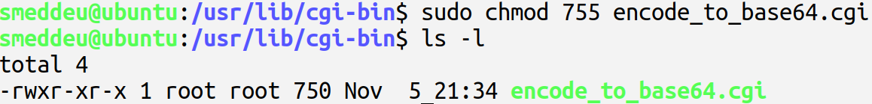

* Using the form from the html file the user submits his name, title, and some text that he/she

wants to convert into Base64 format.

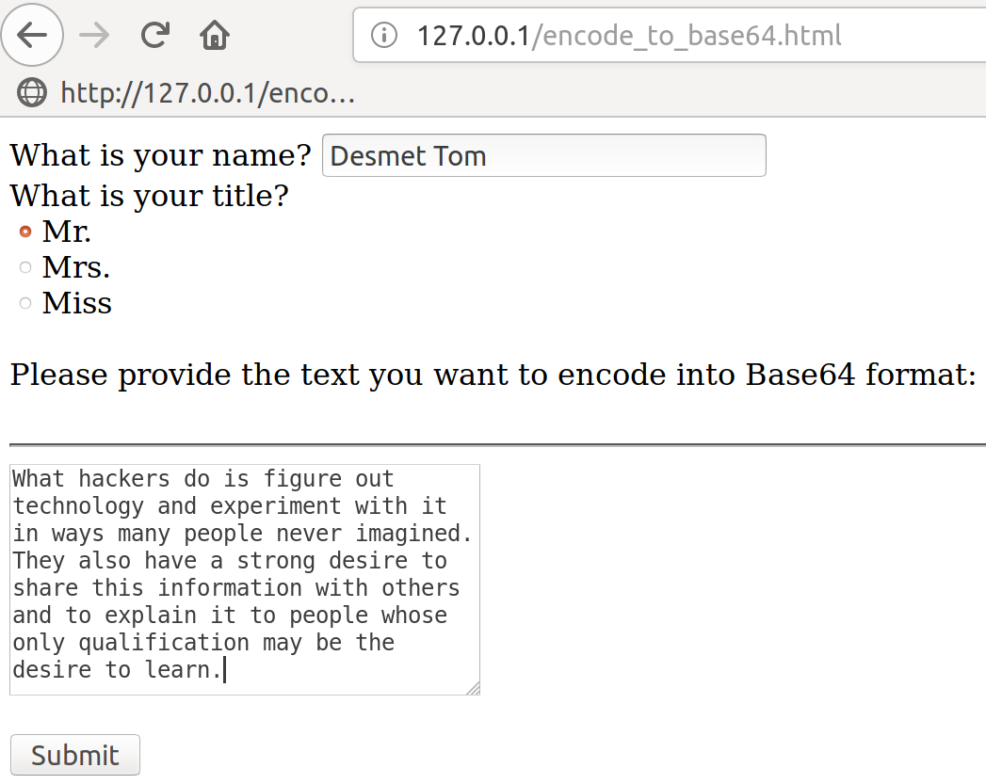

* Use the "openssl base64" command in the script.
* The form uses the HTTP POST method to send the form fields to the cgi script.

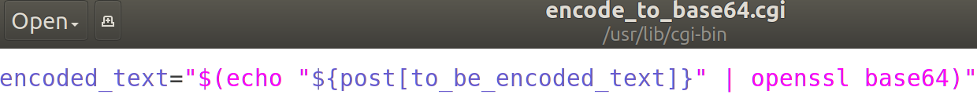

# Task:

Your task is to ensure that "name", "title" and "Base64 encoded string" are returned properly

to the user. Fill in the two missing code blocks indicated by "-->COMPLETE HERE !!!"

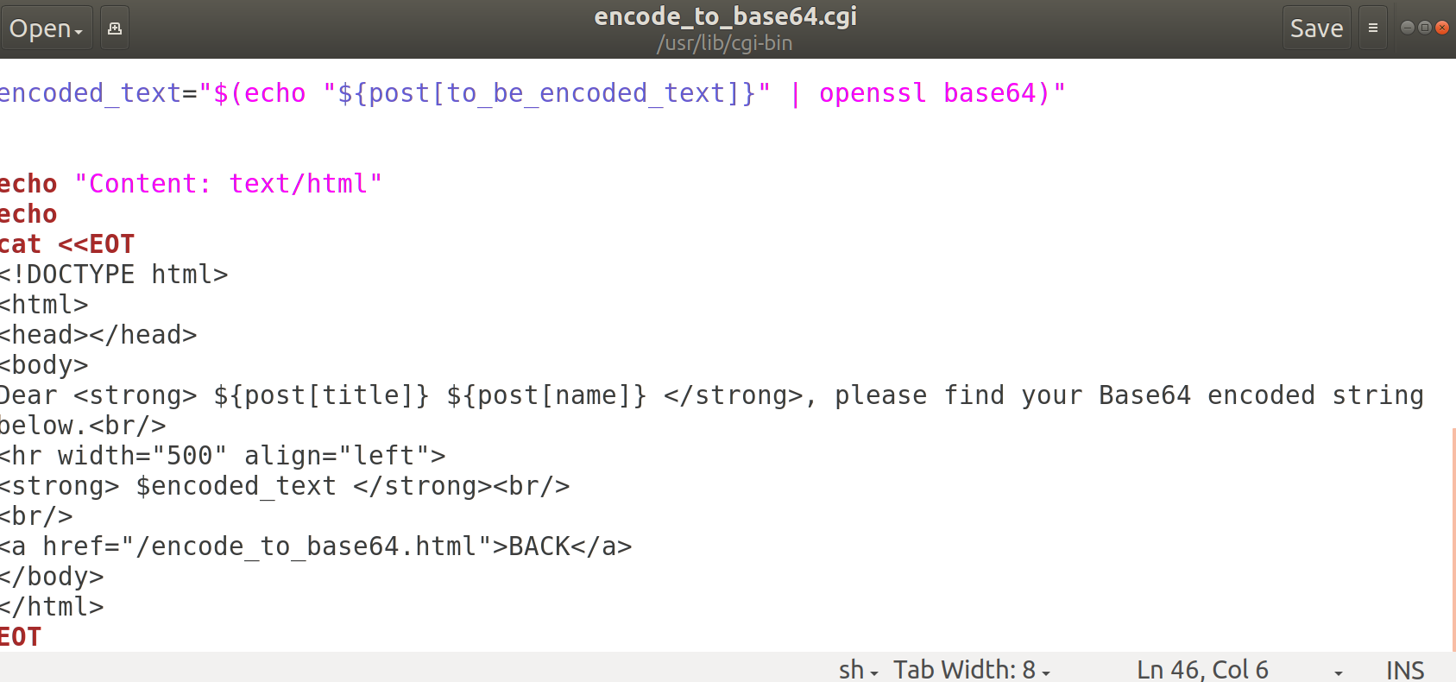

# Result:

